Department of Computer Science and Engineering (Data Science)
CSDS-A | Batch A13 (CSE - Data Science, Section A)
AI-Enabled Digital Examination Seating Management System
(SeatWise)
S.No. | Student name | Roll / hall ticket no.
1 | A.SANJAY | 23K91A6702
2 | CH.NAVEEN | 23K91A6743
3 | D.KOTESH | 24K95A6705
4 | A.AKSHITH | [Roll number to be confirmed]
Under the guidance of: [GUIDE NAME], [DESIGNATION]
SCOPE AND LIMITATIONS
This document states what SeatWise covers and what it deliberately does not, the assumptions behind the design, and the honest limitations of the system and of the evidence for it.

1 Scope of the Project

1.1 In scope
- Validated import of courses, halls, candidates and the timetable from Excel or CSV files, with row-level error reports.
- Constraint-optimised seating for each sitting: capacity, no same-paper neighbours (8-neighbour or 4-neighbour adjacency), a configurable roll-number gap, accessible seats, department mix, and compact or balanced use of halls.
- Seeded randomisation, reproducibility, fingerprints, a Verify action, and an append-only audit trail.
- A seat map with drag-and-drop swaps that checks every move against the same rules.
- Outputs: seating charts and invigilator sheets (PDF), hall lists and attendance report (Excel), seat slips with QR codes (PDF).
- Tablet-friendly attendance, a public seat-lookup page, analytics, team management with two roles, and editable default rules.
- An evaluation harness (benchmark) that compares the engine with sequential, round-robin and random seating.

1.2 Out of scope
- Timetabling itself: the timetable is an input; SeatWise does not decide which papers share a sitting.
- Invigilator duty rostering beyond an even, automatic assignment of one invigilator per hall.
- Online or remote proctoring, face recognition, biometric attendance, and result processing.
- Cloud hosting, multi-institution tenancy, e-mail or SMS delivery, and payment or fee features.
- Training machine-learning models: the engine is a constraint model, and nothing is learnt from data.

1.3 Assumptions
- A candidate's neighbours are the seats directly in front, behind, beside and (in 8-neighbour mode) diagonal to the candidate's seat. Aisles break adjacency across them. Cheating beyond that distance is outside the model.
- A roll number is a text prefix followed by a number (for example ACF24017); the roll-gap rule compares numbers that share a prefix.
- Two courses that share a question paper are declared as one paper group in the timetable, are examined in the same sitting, and count as one paper for separation.
- The system runs on one machine for one institution; the administrator is trusted to import correct data.

2 System Boundary
The two diagrams below show the boundary of SeatWise: what flows across it (context diagram) and who may do what inside it (use-case diagram).
The context diagram shows SeatWise as a single process with three external entities. The exam controller sends data files, rules, a seed and swap or publish commands, and receives validation reports, plans, scorecards, charts, lists, analytics and the audit trail. The invigilator sends attendance marks and scanned slips and receives hall lists, seat maps and register counts. The candidate sends a candidate ID and receives the hall, the seat, a hall map and a QR slip.
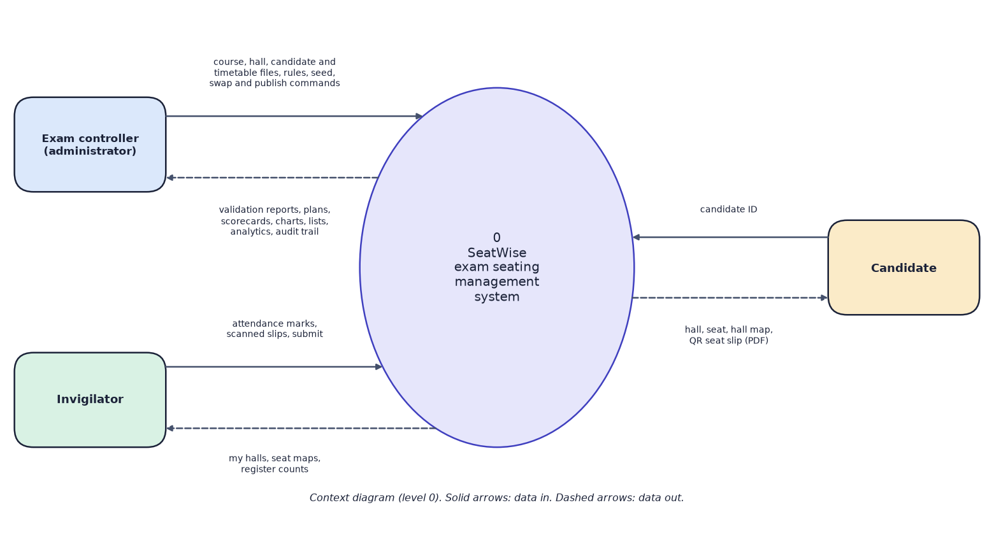
Fig. 1: Data-flow diagram, level 0 (context diagram)
The administrator can import and validate data, set rules, generate, verify, swap, publish and export plans, view analytics and the audit trail, and manage the team. The invigilator can request an account, view assigned halls, mark attendance, submit and lock the register, and print the chart or sheet of an assigned hall. The candidate needs no account and can look up a seat and download a QR slip. Everyone who is signed in must first sign in.
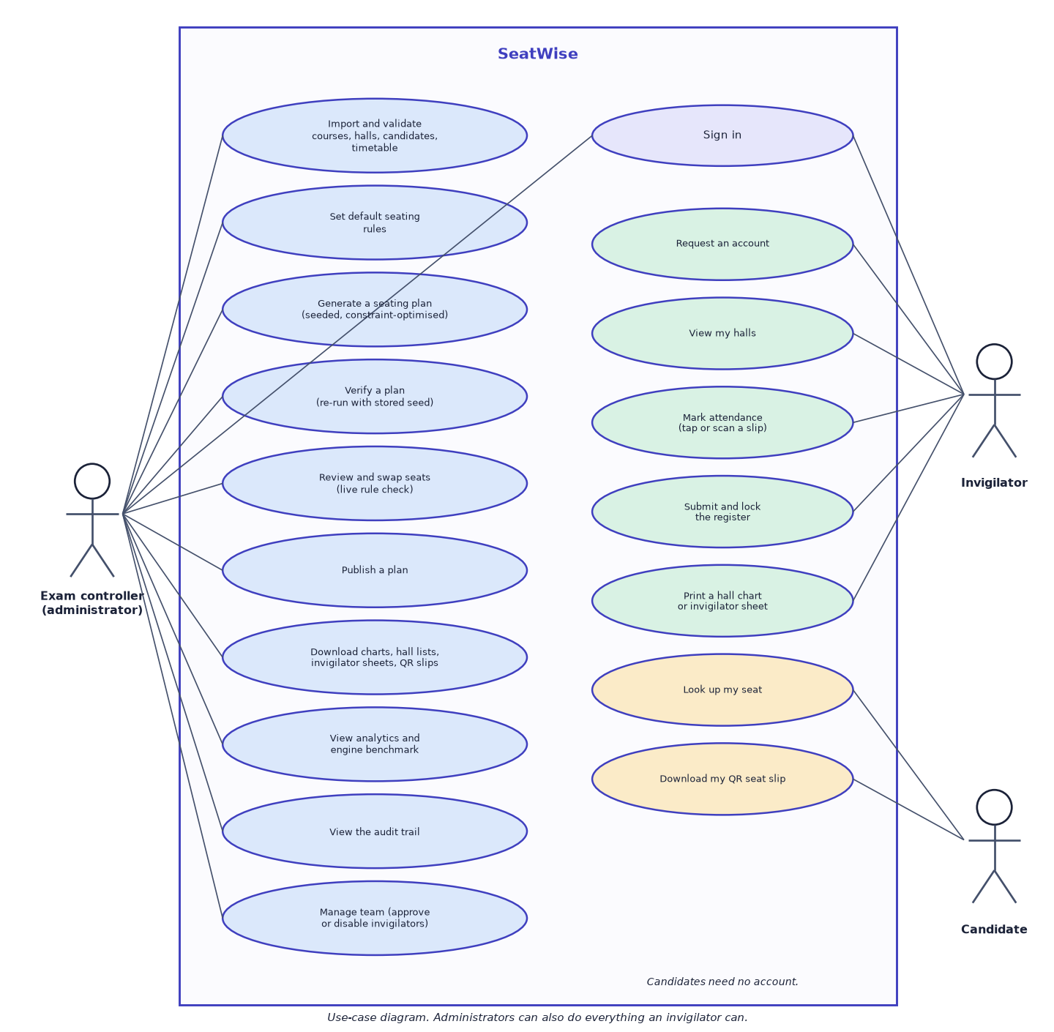
Fig. 2: Use-case diagram

3 Limitations and Assumptions
The limitations below are properties of the delivered system and of the evidence for it. They are repeated, with measurements, in Chapters 7 and 8.
- Synthetic data only. All data used for development, testing and evaluation was generated by a seeded script. No real examination data and no real users were involved, so real-world performance is not established.
- No user-acceptance testing. The interface was exercised by automated tests, scripted scenarios and manual walkthroughs, but not by real invigilators or examination staff.
- Single machine, one benchmark run. The benchmark was run once on a 12-thread Windows desktop. Other hardware, memory use and many simultaneous users were not measured. SQLite is suited to one office, not to many institutions.
- Front-row bias. Because each paper occupies one colour class per hall and only two of the four classes include the front row, departments are slightly unevenly spread over the front row (4.7 percentage points, against 1.6 for a random shuffle).
- Four-neighbour mode is slower (6.0 s against 2.4 s for 600 candidates) because each class covers half the hall.
- Capacity limit per paper. A single paper cannot occupy more than the largest colour class of each hall; the engine refuses larger requests with an explanation rather than breaking a rule.
- No machine learning. There is no accuracy, precision, recall or F1 to report, because nothing is trained.
- Camera scanning works only where the browser allows camera access (localhost or HTTPS); otherwise a hand-held scanner or typing is used.

4 Advantages and Constraints

4.1 Advantages
- Guaranteed rule compliance, checked by an independent validator.
- Seconds instead of days; any plan can be regenerated or compared.
- Reproducible and auditable plans; one stored plan serves charts, slips, lookup and attendance.
- Free software, offline operation, simple Windows setup (setup.bat, run.bat).

4.2 Constraints
- One machine and one SQLite database: suitable for one institution, not for many.
- Solve time grows with the number of halls and is higher in 4-neighbour mode.
- A single paper larger than the colour-class capacity of the selected halls cannot be seated; more halls are needed.
- Evidence is from synthetic data; real-world validation is future work.

5 Limits of the Testing Done
- All test data is synthetic; real examination data may contain cases that the generator does not.
- The front end has no automated component or end-to-end test suite; it is checked by a strict type check, a production build and manual walkthroughs.
- The benchmark was run once on one machine; variation between machines and between runs was not studied beyond three seeds.
- No load, memory, security-penetration or accessibility-audit tests were carried out.
- The 58 tests check behaviour that the team thought of; they cannot prove the absence of defects.

6 Discussion of Limitations
- Synthetic data. Every number in this chapter comes from seeded synthetic sittings; real institutions' data may differ in paper sizes, hall shapes and roll-number formats.
- One machine, one run. The benchmark ran once on one desktop with three seeds per scenario. We did not study variation between machines, and we did not measure memory or concurrent use.
- No user study. The usability of the seat map, the attendance screen and the lookup page was not tested with real users.
- No accuracy-style metrics. Because nothing is trained, accuracy, F1 and confusion matrices do not exist; the benchmark measures rule violations and speed instead.
- Base-paper comparison is qualitative. The base paper reports no measurements; the round-robin baseline is a proxy, not a re-implementation.
- Front-row bias and 4-neighbour speed are known weaknesses, described above.

